

**MALIGNANT COMMENTS CLASSIFIER PROJECT REPORT**

Submitted by:

HIMANI UNIYAL

**ACKNOWLEDGMENT**

I would like to express my deepest gratitude to my SME (Subject Matter Expert) Swati Mahaseth as well as Flip Robo Technologies who gave me the opportunity to do this project on Malignant Comments Classification, which also helped me in doing lots of research wherein I came to know about so many new things especially the Natural Language Processing and Natural Language Toolkit parts.

Also, I have utilized a few external resources that helped me to complete this project. I ensured that I learn from the samples and modify things according to my project requirement. All the external resources that were used in creating this project are listed below:

1) <https://www.google.com/>

2) <https://www.youtube.com/>

3) <https://scikit-learn.org/stable/user_guide.html>

4) <https://github.com/>

5) <https://www.kaggle.com/>

6) <https://medium.com/>

7) <https://towardsdatascience.com/>

8) <https://www.analyticsvidhya.com/>

**INTRODUCTION**

* Business Problem Framing

The proliferation of social media enables people to express their opinions widely online. However, at the same time, this has resulted in the emergence of conflict and hate, making online environments uninviting for users. Although researchers have found that hate is a problem across multiple platforms, there is a lack of models for online hate detection.

Online hate, described as abusive language, aggression, cyberbullying, hatefulness and many others has been identified as a major threat on online social media platforms. Social media platforms are the most prominent grounds for such toxic behaviour.

There has been a remarkable increase in the cases of cyberbullying and trolls on various social media platforms. Many celebrities and influences are facing backlashes from people and have to come across hateful and offensive comments. This can take a toll on anyone and affect them mentally leading to depression, mental illness, self-hatred and suicidal thoughts.

Our goal is to build a prototype of online hate and abuse comment classifier which can used to classify hate and offensive comments so that it can be controlled and restricted from spreading hatred and cyberbullying.

* Conceptual Background of the Domain Problem

Online platforms and social media become the place where people share the thoughts freely without any partiality and overcoming all the race people share their thoughts and ideas among the crowd.

Social media is a computer-based technology that facilitates the sharing of ideas, thoughts, and information through the building of virtual networks and communities. By design, social media is Internet-based and gives users quick electronic communication of content. Content includes personal information, documents, videos, and photos. Users engage with social media via a computer, tablet, or smartphone via web-based software or applications.

While social media is ubiquitous in America and Europe, Asian countries like India lead the list of social media usage. More than 3.8 billion people use social media.

In this huge online platform or an online community there are some people or some motivated mob wilfully bully others to make them not to share their thought in rightful way. They bully others in a foul language which among the civilized society is seen as ignominy. And when innocent individuals are being bullied by these mob these individuals are going silent without speaking anything. So, ideally the motive of this disgraceful mob is achieved.

To solve this problem, we are now building a model that identifies all the foul language and foul words, using which the online platforms like social media principally stops these mob using the foul language in an online community or even block them or block them from using this foul language.

* Review of Literature

The purpose of the literature review is to:

1. Identify the foul words or foul statements that are being used.

2. Stop the people from using these foul languages in online public forum.

To solve this problem, we are now building a model using our machine language technique that identifies all the foul language and foul words, using which the online platforms like social media principally stops these mob using the foul language in an online community or even block them or block them from using this foul language.

.

.

Our goal is to build a prototype of online hate and abuse comment classifier which can used to classify hate and offensive comments so that it can be controlled and restricted from spreading hatred and cyberbullying.

* Motivation for the Problem Undertaken

One of the first lessons we learn as children is that the louder you scream and the bigger of a tantrum you throw, you more you get your way. Part of growing up and maturing into an adult and functioning member of society is learning how to use language and reasoning skills to communicate our beliefs and respectfully disagree with others, using evidence and persuasiveness to try and bring them over to our way of thinking.

With widespread usage of online social networks and its popularity, social networking platforms have given us incalculable opportunities than ever before, and its benefits are undeniable. Despite benefits, people may be humiliated, insulted, bullied, and harassed by anonymous users, strangers, or peers. In this study, we have proposed a cyberbullying detection framework to generate features from online content by leveraging a pointwise mutual information technique. Based on these features, we developed a supervised machine learning solution for cyberbullying detection and multi-class categorization of its severity. Results from experiments with our proposed framework in a multi-class setting are promising both with respect to classifier accuracy and f-measure metrics. These results indicate that our proposed framework provides a feasible solution to detect cyberbullying behaviour and its severity in online social networks.

**Analytical Problem Framing**

* Mathematical/ Analytical Modeling of the Problem

Here in this project, we have been provided with two datasets namely train and test CSV files. I will build a machine learning model by using NLP using train dataset. And using this model we will make predictions for our test dataset.

I will need to build multiple classification machine learning models. Before model building will need to perform all data pre-processing steps involving NLP. After trying different classification models with different hyper parameters then will select the best model out of it. Will need to follow the complete life cycle of data science that includes steps like -

1. Data Cleaning

2. Exploratory Data Analysis

3. Data Pre-processing

4. Model Building

5. Model Evaluation

6. Selecting the best model

* Data Sources and their formats

The data set contains the training set, which has approximately 1,59,000 samples and the test set which contains nearly 1,53,000 samples. All the data samples contain 8 fields which includes ‘Id’, ‘Comments’, ‘Malignant’, ‘Highly malignant’, ‘Rude’, ‘Threat’, ‘Abuse’ and ‘Loathe’. The label can be either 0 or 1, where 0 denotes a NO while 1 denotes a YES. There are various comments which have multiple labels. The first attribute is a unique ID associated with each comment.

The data set includes:

Malignant: It is the Label column, which includes values 0 and 1, denoting if the comment is malignant or not.

Highly Malignant: It denotes comments that are highly malignant and hurtful.

Rude: It denotes comments that are very rude and offensive.

Threat: It contains indication of the comments that are giving any threat to someone.

Abuse: It is for comments that are abusive in nature.

Loathe: It describes the comments which are hateful and loathing in nature.

ID: It includes unique Ids associated with each comment text given.

Comment text: This column contains the comments extracted from various social media platforms.

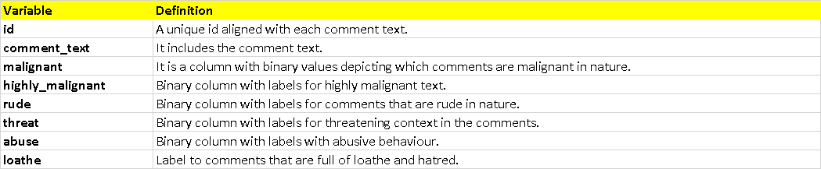

This project is more about exploration, feature engineering and classification that can be done on this data. Since the data set is huge and includes many categories of comments, we can do good amount of data exploration and derive some interesting features using the comments text column available. You need to build a model that can differentiate between comments and its categories.

* Data Preprocessing Done

The following pre-processing pipeline is required to be performed before building the classification model prediction:

1. Load dataset

2. Remove null values

3. Drop column id

4. Convert all messages to lower case.

5. Replace email addresses with 'email'

6. Replace URLs with 'webaddress'

7. Replace money symbols with 'moneysymb' (£ can by typed with ALT key + 156)

8. Replace 10 digit phone numbers (formats include paranthesis, spaces, no spaces, dashes) with 'phonenumber'

9. Replace numbers with 'numbr'

10. Total length removal

* Data Inputs- Logic- Output Relationships

I have analysed the input output logic with word cloud and I have word clouded the sentenced that as classified as foul language in every category. A tag/word cloud is a novelty visual representation of text data, typically used to depict keyword metadata on websites, or to visualize free form text. It’s an image composed of words used in a particular text or subject, in which the size of each word indicates its frequency or importance.

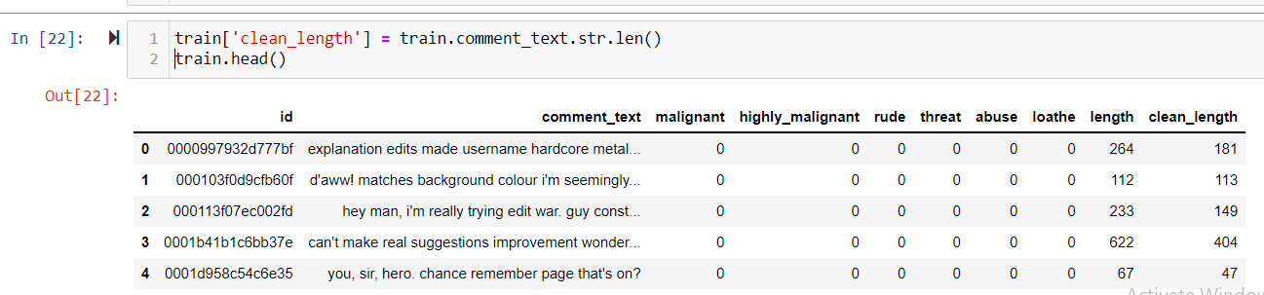

These are the comments that belongs to different type so which the help of word cloud we can see if there is abuse comment which type of words it contains and similar to other comments as well.

* State the set of assumptions (if any) related to the problem under consideration

Cyberbullying has become a growing problem in countries around the world. Essentially, cyberbullying doesn’t differ much from the type of bullying that many children have unfortunately grown accustomed to in school. The only difference is that it takes place online.

Cyberbullying is a very serious issue affecting not just the young victims, but also the victims' families, the bully, and those who witness instances of cyberbullying. However, the effect of cyberbullying can be most detrimental to the victim, of course, as they may experience a number of emotional issues that affect their social and academic performance as well as their overall mental health.

* Hardware and Software Requirements and Tools Used

Hardware technology being used.

RAM : 8 GB

CPU : AMD Ryzen 5 3550H with Radeon Vega Mobile Gfx 2.10 GHz

GPU : AMD Radeon ™ Vega 8 Graphics and NVIDIA GeForce GTX

1650 Ti

Software technology being used.

Programming language : Python

Distribution : Anaconda Navigator

Browser based language shell : Jupyter Notebook

Libraries/Packages specifically being used.

Pandas, NumPy, matplotlib, seaborn, scikit-learn, pandas-profiling, missingno, NLTK

**Model/s Development and Evaluation**

* Identification of possible problem-solving approaches (methods)

I checked through the entire training dataset for any kind of missing values information and all these pre processing steps were repeated on the testing dataset as well.

Code:

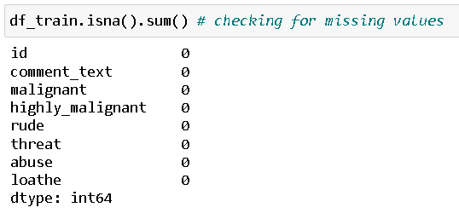

Visual Representation:

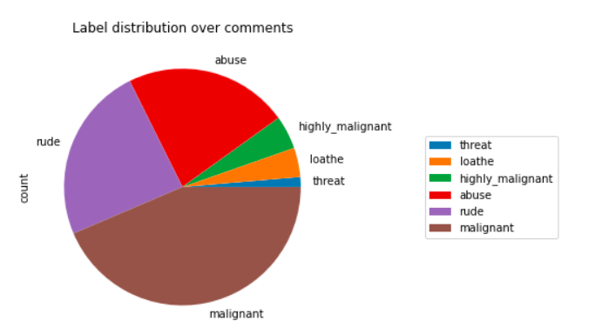

* Testing of Identified Approaches (Algorithms)

The complete list of all the algorithms used for the training and testing classification model are listed below:

1. Logistic Regression
2. Random Forest Classifier

* Run and Evaluate selected models

I created a classification function that included the evaluation metrics details for the generation of our Classification Machine Learning models.

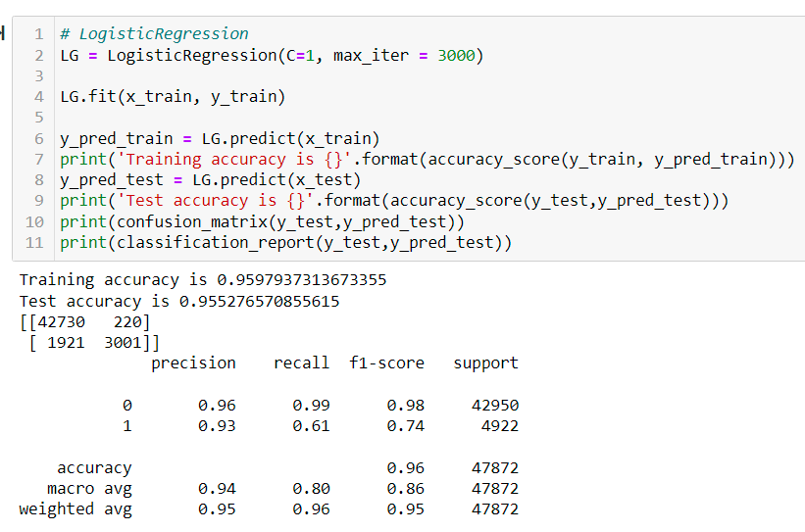

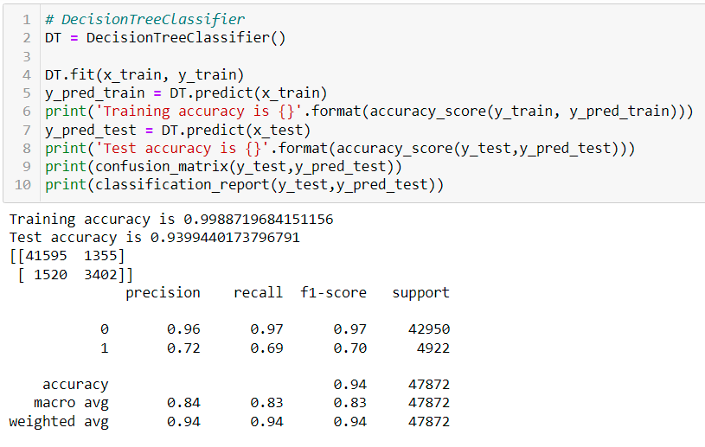

* Interpretation of the Results

Starting with univariate analysis, with the help of count plot it was found that dataset is imbalanced with having higher number of records for normal comments than bad comments (including malignant, highly malignant, rude, threat, abuse and loathe). Also, with the help of distribution plot for comments length it was found that after cleaning most of comments length decreases from range 0-1100 to 0-900. Moving further with word cloud it was found that malignant comments consists of words like fuck, nigger, moron, hate, suck etc. highly_malignant comments consists of words like ass, fuck, bitch, shit, die, suck, faggot etc. rude comments consists of words like nigger, ass, fuck, suck, bullshit, bitch etc. threat comments consists of words like die, must die, kill, murder etc. abuse comments consists of words like moron, nigger, fat, jew, bitch etc. and loathe comments consists of words like nigga, stupid, nigger, die, gay, cunt etc.

**CONCLUSION**

* Key Findings and Conclusions of the Study

The finding of the study is that only few users over online use unparliamentary language. And most of these sentences have more stop words and are being quite long. As discussed before few motivated disrespectful crowds use these foul languages in the online forum to bully the people around and to stop them from doing these things that they are not supposed to do. Our study helps the online forums and social media to induce a ban to profanity or usage of profanity over these forums.

* Learning Outcomes of the Study in respect of Data Science

Through this project we were able to learn various Natural language processing techniques like lemmatization, stemming, removal of stopwords. We were also able to learn to convert strings into vectors through hash vectorizer. In this project we applied different evaluation metrics like log loss, hamming loss besides accuracy.

* Limitations of this work and Scope for Future Work

Problems faced while working in this project:

* Imbalanced dataset and bad comment texts
* Good parameters could not be obtained using hyperparameter tuning as time was consumed more

Areas of improvement:

* Could be provided with a good dataset which does not take more time.
* Less time complexity
* Providing a proper balanced dataset with less errors.